Hoʻokipa Building

Counseling Department 2015-2016 (2016) ASSESSMENT REPORT
MISSION
The mission of the University Hawai‘i Maui College Counseling Department is to provide services that assist students in realizing their educational goals.
- The Counseling Department serves enrolled and non-enrolled students including prospective, returning, and transfer students.
- The Counseling Department supports students in articulating, developing, and meeting educational, career, and personal goals.
- The Counseling Department supports the college community with recruitment, persistence, and retention efforts as well as initiatives to increase graduation and transfer rates.

GOALS

Overall Outcomes for Student Affairs:
- Enrollment: Target key enrollment sectors that are underserved or have recruitment potential to expand access
  - Require all new first time students to meet with an academic advisor prior to enrollment
  - Increase dual credit/enrollment with local area high schools
- Hawaii Graduation Initiative: Increase the participation and completion rates of students, particularly Native Hawaiian, low-income, and those from underserved regions
  - Participate in STAR Auto Credential and Reverse transfer
  - Participate in Automatic Admissions, Ka‘ie‘ie Transfer agreement
- High Performance: Identify and change structures and processes that potentially impede student progress or student success
  - Implement My Success (Starfish) retention tool to increase student progress and students success

STUDENT LEARNING OUTCOMES FOR COUNSELING

The following Student Learning Outcomes will be used for the counseling department (adapted from the CAS Standards)

~Knowledge Acquisition: understanding knowledge from a range of disciplines; connecting knowledge to other knowledge, ideas and experiences; and relating knowledge to daily life.

- STAR Registration: By Fall 2017 100% of the Maui College Student body will use STAR GPS to register for classes.

~Intrapersonal Development: Dimensions: realistic self-appraisal, self-understanding, and self-respect; identity development;commitment to ethics and integrity; and spiritual awareness.

- My Success Flag Response: By Fall 2017 75% of students who are flagged on the Early Alert (FLAG 1) will be followed up with.

DEPARTMENTAL DASHBOARD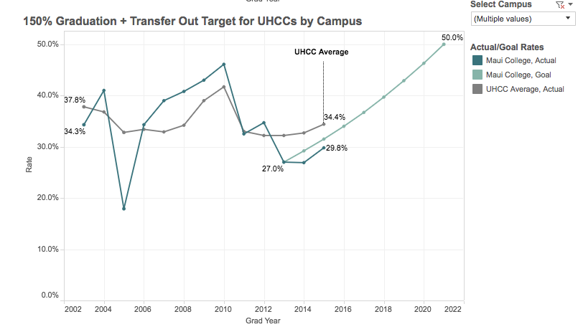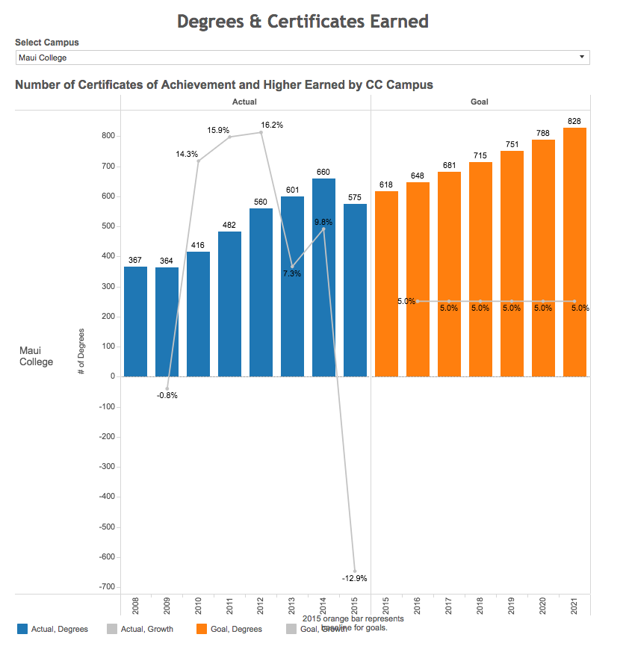

POINTS OF PRIDE
The Counseling Department has worked to provide quality services to students and increase access points for all enrolled and prospective student. Here is a summary of achievements:
- Continued to require all new first time students to meet with an academic advisor prior to enrollment as part of the New Student Registration process.
- Continued to expand and implement student retention software called My Success (Starfish). This software consists of an early alert, appointment scheduling feature and student folder. As a result of the early alert surveys, counseling responded to 800 tracking items raised utilizing the My Success tool for the Early Alert Survey. The students were contacted to better understand what they were struggling with in the classes that raised concerns.
- Lead builder for STAR degree audit system for Maui College. As of Fall 2016 all programs and program plans are built and able to be used by all new students.

ASSESSMENT ACTIVITIES 2015-2016

Program Objective 1

Provide access and opportunities for student enrollment: Target key enrollment sectors that are underserved or have recruitment potential to expand access

Methods and Measures

- Require all new first time students to meet with an academic advisor prior to enrollment
- Increase dual credit/enrollment opportunities with local area high schools
- Develop pathways for students to enroll at Maui College and then transfer to a four year program
- Participate in Automatic Admissions and Kaʻieʻie Transfer

Findings
Early Admit (including Running Start, grant funded initiatives)
 | FALL |  | SPRING |  | SUMMER
2015-2016 | 254 |  | 270 |  | 141
2014-2015 | 121 |  | 151 |  | 13
2013-2014 | 120 |  | 96 |  | 11
2012 - 2013 | 62 |  | 57 |  | 3

Automatic Admissions- automatic admissions to one of the four-year UH schools including UH Manoa, Hilo and West O’ahu.

 | FALL |  | SPRING
2015-2016 | 35 |  | 93
2014-2015 | 33 |  | 84
2013-2014 | 49 |  | 75
2012 - 2013 | 21 |  | 71

Program Objective 2

Increase the participation and completion rates of students, particularly Native Hawaiian, low-income, and those from underserved regions

Methods and Measures

- 15 to finish- Student understands the timeframe involved with graduating within a two year timespan for an associate’s degree
- Participate in STAR Auto Credential and Reverse transfer
- Participate in Learning Support Teams (Hanai Class) initiative for Learning Support courses (developmental courses)

Findings

Regardless of academic preparation students who take 15 or more credits have a higher credit completion rate of courses.
Semester | % of student body taking 15+ credits
Fall 2016 | 11%
Fall 2015 | 20%
Fall 2014 | 8.6%
Source: Hawaii Graduation Initiative

Reverse Transfer- Students who have transferred to a UH four-year school without earning a AA/AS can apply the credits that they have taken at the four-year school towards an AA. These numbers reflect the amount of AA/AS degree awarded at Maui College.

 | FALL |  | SPRING
2015-2016 | 22 |  | TBA
2014-2015 | 21 |  | 29
2013-2014 | 34 |  | 1

Program Objective 3

Institutionalizing Assistive Technology

The Disability Services (DS) Counselor/Coordinator has specialized training in working with people with disabilities and is responsible for evaluating the academic limitations of individuals with disabilities and determining their needs to promote academic access. The DS Counselor/Coordinator provides reasonable academic accommodations and modifications, and monitor implementation of services as required by various civil rights law. The DS Coordinator/Counselor also provides academic advising and career counseling. In addition to being the sole provider for disability accommodations, additional responsibilities such as maintaining an advising caseload, management of the Assistive Technology Lab, provide content in alternative text, supervise on campus service providers, and liaise with faculty and staff and community service providers.

While students served by the DS Counselor/Coordinator has increased by 74% since FY09, students serviced in 2014-2015 decreased by 50% due to a vacancy in the position and the duties were disseminated between two Academic Counselors with full caseloads.

UHMC DISABILITY SERVICES DATABASE (UNDUPLICATED COUNT OF STUDENTS)
 | 2015-2016 | %C | 2014-  2015 | %C | 2013-2014 | %C | 2012-2013 | %C | 2011-2012 | %C | 2010-2011 | %C | 2009-2010
Disability Services Counselor | 170 |  | 143 | -50% | 286 | 0% | 287 | 7.9 | 266 | 20.4 | 221 | 14.5 | 193

Students served by the Disability Services Coordinator remained steady from FY 15 to FY 16.
Primary disability ranges from Psychiatric to Learning, to Physical.

The Counseling Department continues to request for the AT specialist position. This position worked with instructional faculty (our primary priority) and on some things on the UHMC website (pages for the counseling department and disability services information), there was no work done with the instructional designer(s), as the college transitioned to instructional designer positions working on specific projects funded by other grants.

Captioning software was obtained at the end of the grant period (May 2014); captioning videos for faculty will begin in the 2014-15 academic year. Furthermore, as a result of the last UHMC’s Strategic Planning Day, institutionalizing the assistive technology position was considered a priority. The position was viewed as serving special populations which include those students qualified for reasonable accommodations. The special populations include students with disabilities, and may extend as well to veterans, English language learners, etc. Given the scope of services that may need to be in place, this position is essential for the delivery of accommodation.

PLANS FOR THE COMING YEAR

15 to finish- Continue to promote and teach students the benefits of course load and how they can make the best use of their time in school.

STAR Registration- Continue to build and maintain all STAR degree pathways and records. This is critical for the functionality of system.

Alternative placement- Continue to create a workflow to support the alternative placement factors for students and allow them to place at college level English and Math courses.

Learning Support Teams- Continue to partner with English and Math instructors to support the students who are enrolled in the learning supports courses (developmental education courses)

BUDGET CONSIDERATIONS FOR COMING YEAR

STAR Building overload (40 hours per week)
Student Assistants
First Year Experience Counselor
APT Assistive Technology Specialist

